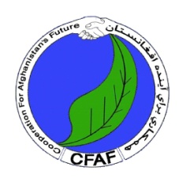
Cooperation for Afghanistan Future Organization
Health Department
Mothly Vaccination Report/ Rapporto Vaccinazione Mensile

With Support of International Help Onlus- Torino Italy
Clinica dell’Amicizia Italia-Afghanistan
Con il Sostegno di
International Help Onlus- Torino
 | Vaccination Report |  |  |  | Year/Anno | 2021
 | Children 0-18 months | Dai 0 ai 18 Mesi |  |  | Women 15-45 years | Donne dai 15 ai 45anni
Month/Mese | Girls/Bambine | Boys/Bambini |  | Total | Pregnant/ Incinta | Non pregnant  Non incinta |  | Total
January/ Gennaio | 230 | 180 |  | 410 | 90 | 200 |  | 290
February/ Febbraio | 201 | 229 |  | 430 | 80 | 201 |  | 281
March/ Marzo | 210 | 240 |  | 450 | 59 | 280 |  | 339
Total | 641 | 649 |  | 1290 | 229 | 681 |  | 910

